Web Development Reflective Essay

## Roles and Contributions

**In a Nutshell**

Will and I are the only members of the team to have done any work on the CSS; Annie and Iloise contributed to ideas for the website, the wireframes and important design improvements. They also provided regular feedback on how they thought the site looked.

**Team Reshuffle – Effects and Influence**

Before being assigned to my current team, I was part of another one that included Anastasia with whom I collaborated during this process. The other members of that original team never responded. Before the team reassignment took place, we had already done a significant amount of work and were well on our way to completing the CSS for the theme park website.

Consequently, I was reluctant to let go of the work that I had started and asked Anastasia if it would be fine to keep the theme park idea and my previous work associated with it. This previous work included two reviews of other parks, the HTML coding of all three pages and the text content associated with these pages. I also took a stab at the initial CSS design of the site by writing a style sheet which I applied to all three pages.

Anastasia was responsible for the wireframes and greatly improved upon the stylesheet by adding a banner and customising the colour scheme for the layout. She also improved upon the navigation and look of the footer. She redesigned the CSS for the first page, which was to be a starting point for making the CSS on the remaining two pages look more professional.

After the reshuffle, I asked Anastasia if it was fine to keep the banner and her design for the index page which she kindly agreed to. The idea was to use her design as a prototype for how the rest of the website should look in terms of style.

**Theme Park in the Woods Content – Before the Reshuffle**

I have always been fascinated by the horror genre, especially gothic horror which offers a fascinating insight into the human psyche and social boundaries. Despite this fascination, however, I am something of a scaredy-cat and have never set foot inside a haunted house. I think this is mainly because I do not enjoy cheap thrills and have something of a weak constitution that would cause me to probably faint in a place like that.

Anyhow – irrespective of these fears – I immediately latched upon the idea of a horror themed park. The reason for that is because the idea does not seem to be as generic as a family theme park, and I wanted to have the opportunity to insert some bad puns into the website.

Luckily, Anastasia was quite open to my ideas and helped me flesh them out further in order to transfer them to a working web site. She was the one who suggested having VR as one of the attractions rather than making everything based around it.

Once the outline for the theme park was decided upon, I started writing the content for all the pages. By the time the team reshuffle took place, I had written about 70 % of the page content for the website. To the best of my knowledge, the content written on these pages is entirely mine and thus original work.

**Theme Park in the Woods – After the Reshuffle**

I was fortunate enough to have my current team members be receptive with taking my old theme park idea on board. I especially credit Annie and Iloise for helping me flesh out the web content even more by reviewing additional theme parks, contributing ideas to the structure of the page and designing the wire frames.

While writing the webpage content, I consciously tried to insert bad puns that would remind future visitors of the bad jokes that villains like Freddy Kruger often employ. I also tried to insert as many popular references to horror-based franchises as I could. Indeed, the name of the theme park is a reference to a 2011 horror film called ‘Cabin in the Woods’.

**GitHub Organisation**

In order to facilitate changes and any suggestions made by other team members of the group, I moved the existing work into a GitHub organisation that only members of the team have access to. I also helped other team members gain access to the repository.

**Peer Reviews**

So far, the peer reviews have been constructive and served as good pointers on what to improve upon. In particular, the peer reviews have highlighted just how much the CSS and wireframes needed to be updated and further enhanced. I tried to share whatever feedback I got with the rest of the team in order to improve our project.

**Weekly Meetings**

During the time of writing, we are still in the process of finalising the project and coordinating how Will shall enhance/refine the CSS further. Annie has also agreed to update the wireframes.

## Use of HTML and CSS

**HTML**

The HTML that I wrote mainly consisted of paragraph tags, h1 or h3 headers and unordered lists. This was so that the content could be displayed in an effective way. I also tried to be consistent with how I formatted the HTML tags; I also tried to ensure that the HTML files had comments where they were necessary.

Upon the suggestion of Annie, I decided to add an embedded map into the index page that showcased where the fictional theme park is located. I also incorporated suggestions from Iloise and Annie to include a price list as well as more detailed descriptions of the hotel rooms available. I also altered the HTML where necessary so that they fit in with the updated wireframes.

**CSS and Wireframes**

Any CSS contributions on my part were simplistic and served more as a prototype than any attempt at a more completed project. Moreover, once Anastasia was no longer working with me as a teammate, I found myself in the awkward position of not being able to use Figma as she had done - at least, not as well.

After some fruitless attempts at trying to design wireframes using various online tools and PowerPoint, I gave up and just drew some simplistic ones using Paint. Thankfully, Annie and Ilosie both contributed wireframes that are much better than my shoddy attempts.

As for the CSS, I relied on flex boxes for the CSS; the reason for that is because Anastasia recommended me to do so, and I thought they looked nice on a stylistic level. However, following somewhat mixed reviews from fellow students, Will expanded upon the CSS I initially worked on by adding more features and improving the functionality of it (e.g. animation).

## Positive Aspects Teamwork Experience

Will restored my confidence in the project and improved on it a lot overall. He also showed a great amount of professionalism which also kept me motivated throughout when I was ill. In fact, he agreed to take charge of the project once I had to step back for health reasons related to my IBS.

Annie and Iloise provided constructive criticism on what the site lacked in the early stages of the project. Overall, both helped make the site look better in terms of features as I did not originally include much information on the ticket prices or hotel rooms.

## Negative Aspects Teamwork Experience

Overall, I felt that there was too much radio silence at times and that work should have started a lot earlier. Several times Will would organise meetings where only I, Annie and himself would show up consistently. While Will and Annie were true to their word and delivered upon the work that had to be done, other members of the team would show up once or twice on the Slack channel only to never be heard of again.

For example, Gary pointed out an error in the naming of the image files, but never bothered to upload the fix he made on his local machine to Github. I waited for a whole week until I decided to do it myself. As such, I do not feel that that this exercise was successful in terms of teamwork due to lack of regular communication and overall input from specific members of the team.

## Effects of Team Work on The Quality of the Work

Personally, I feel that incremental work throughout a longer span of time is more effective than ramping up major efforts more closely towards a tight deadline. Therefore, I strongly believe that this project would have ended up being of higher quality if people had started collaborating lot earlier than they did. I also think that more professionalism and less absenteeism on part of some of the team members would have helped improve team morale.

## Tools Used

I used Brackets and a simple text editor throughout the entire process of writing the HTML and CSS. As for the wireframes, I tried using Figma, but quickly decided to give it up on it in favour of Paint (which I felt was less complicated). As for code storage and code trackage, I used Github which is a good tool when it comes to organising larger development projects.

When it came to the text content on the site, I wrote the actual content into the Brackets editor, but then used online spell checkers to clear up any linguistic issues.

**Appendix / Screenshots**

Original work / collaboration efforts with Anastasia

The following screenshots showcase the process of how Anastasia and I fleshed out the ideas for the theme park together.

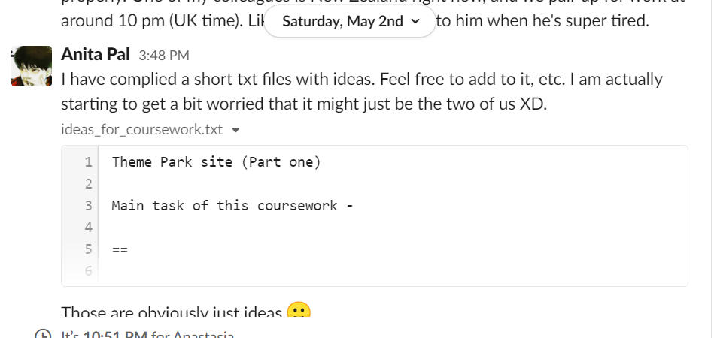

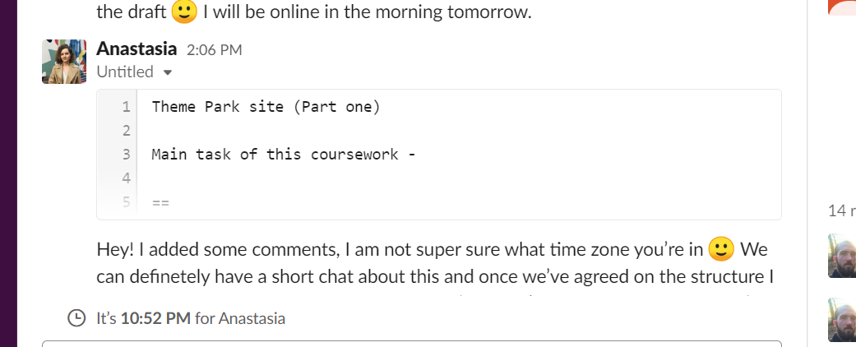

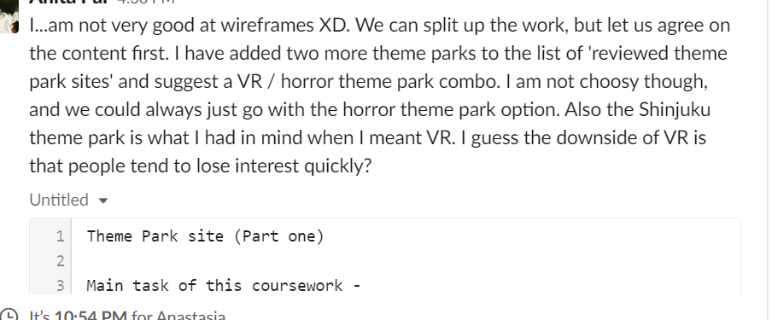

Once we were done with the initial discussion of what we wanted on our site, we decided to do the wireframes, the HTML and the CSS.

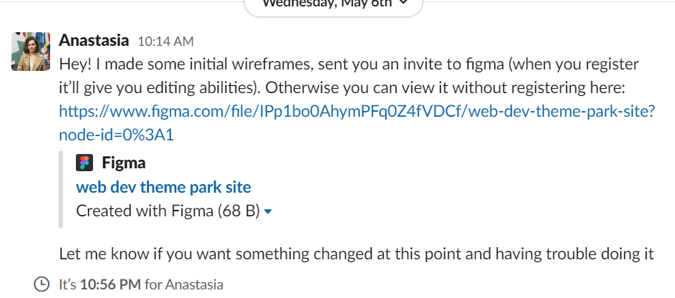

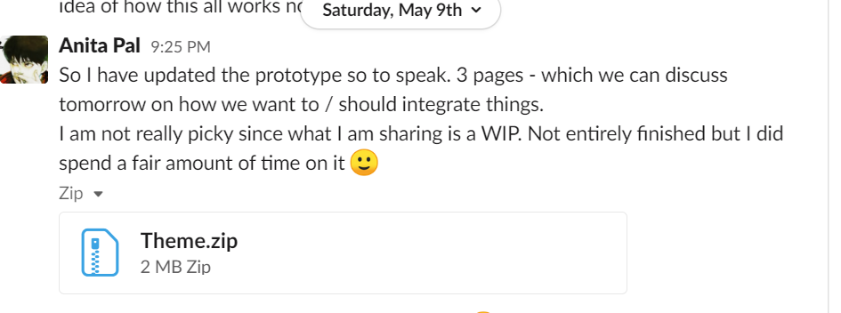

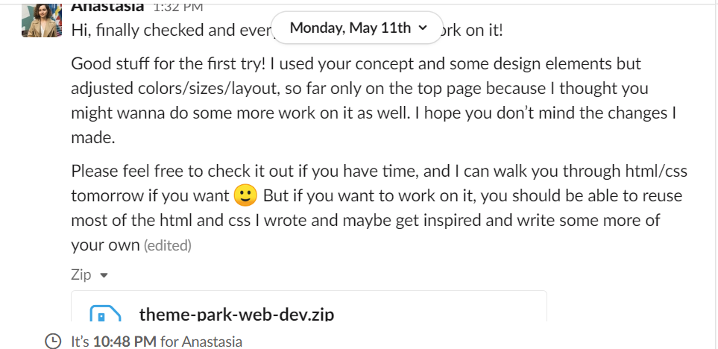

GitHub Organisation

The screenshot below depicts my personal repository where I started hosting the web development project as I worked across several laptops.

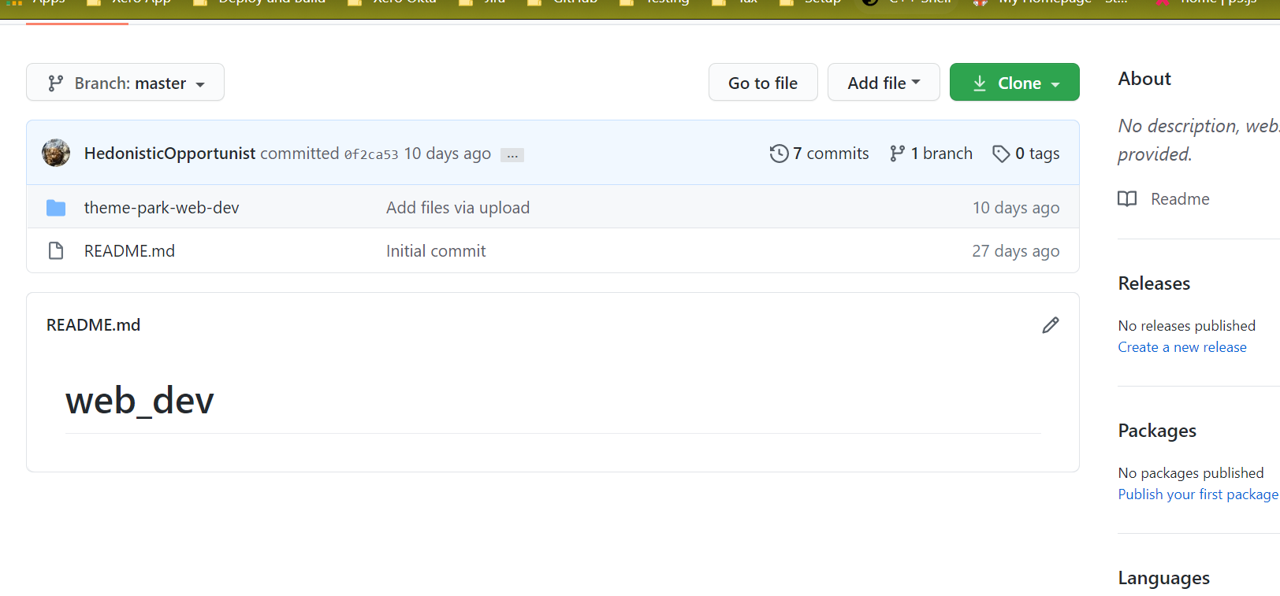

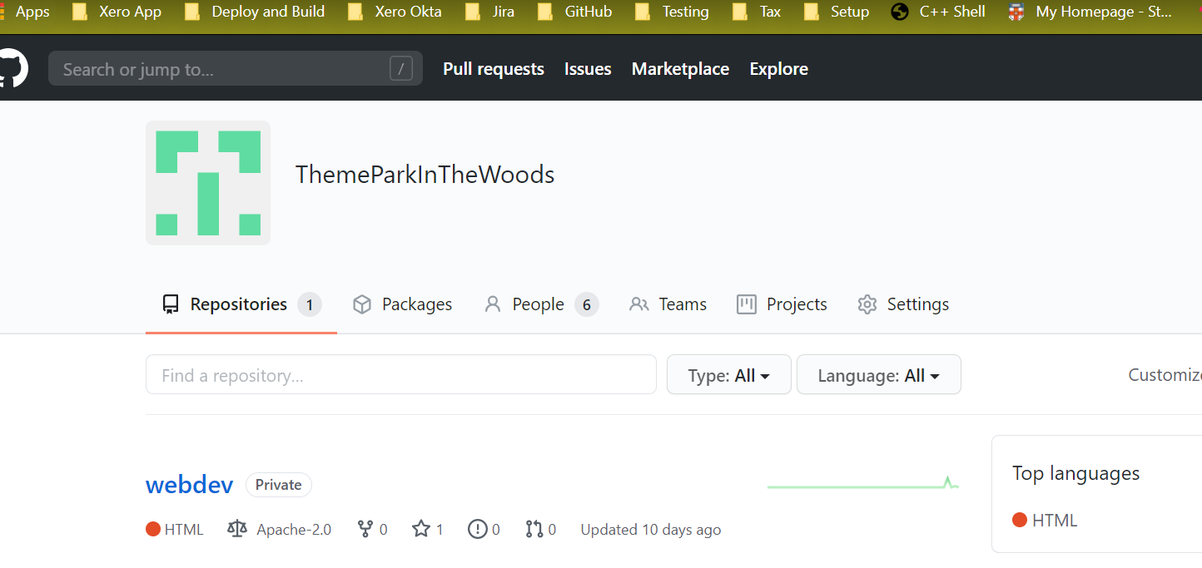

I decided to create an organisation once I realised that it was difficult to share code amongst team members otherwise. The further screenshots document how I sent out invitations to team members.

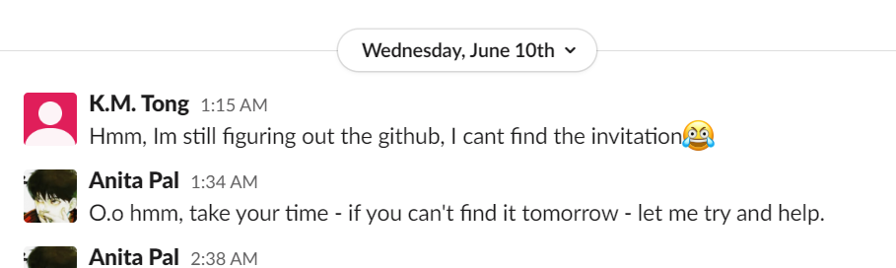

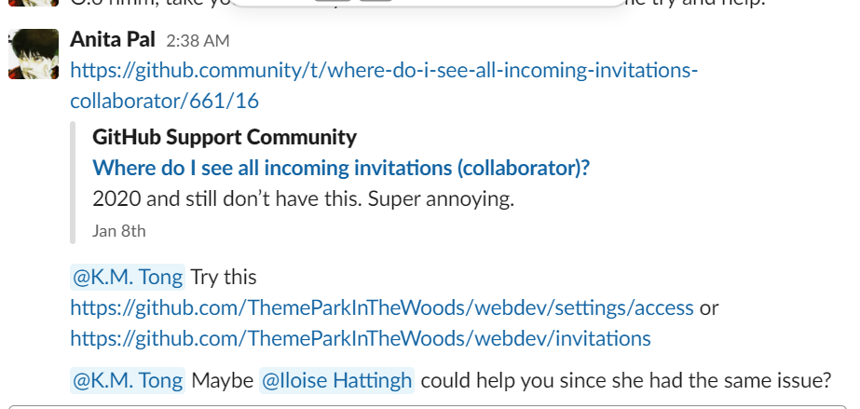

Regular submissions to the Slack channel:

These screenshots showcase the flow between me and the rest of the team. At the beginning, I was heavily active as I wanted the team to start working on the assignment quickly, so that we could have something fully functional by the end of June.

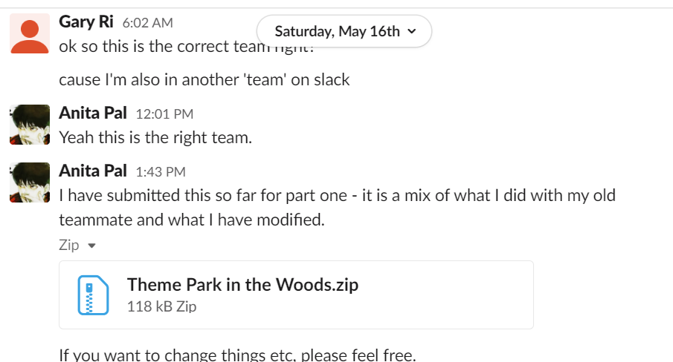

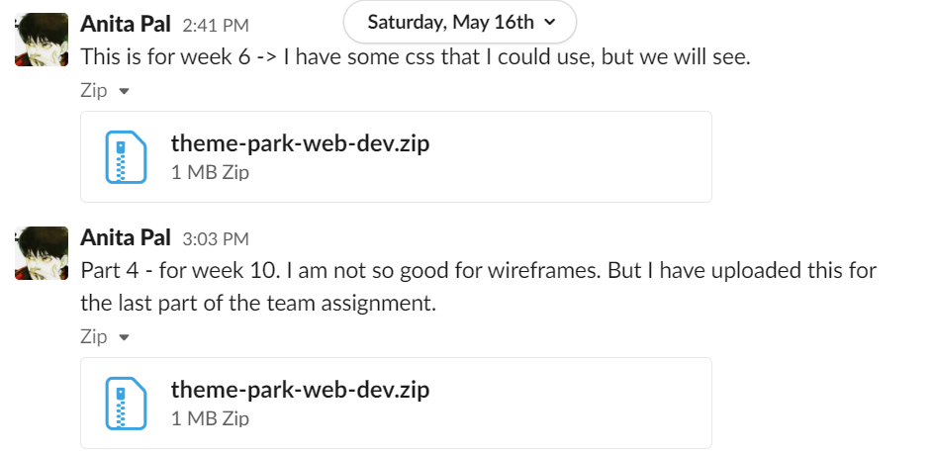

Iloise and Annie were both helpful and active when it came to the fleshing out of ideas for the website. They also helped with the wireframes.

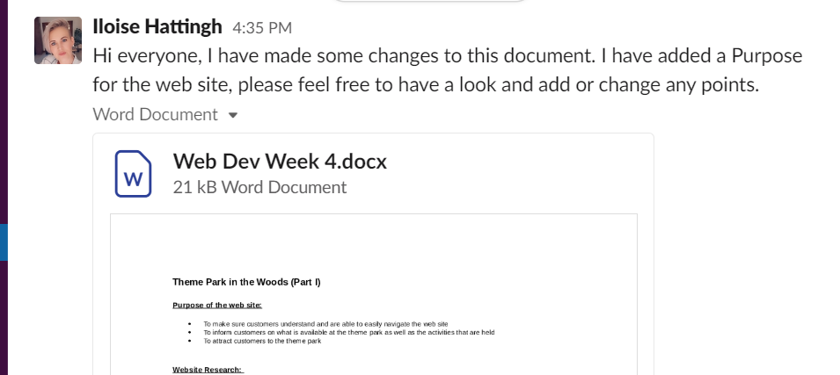

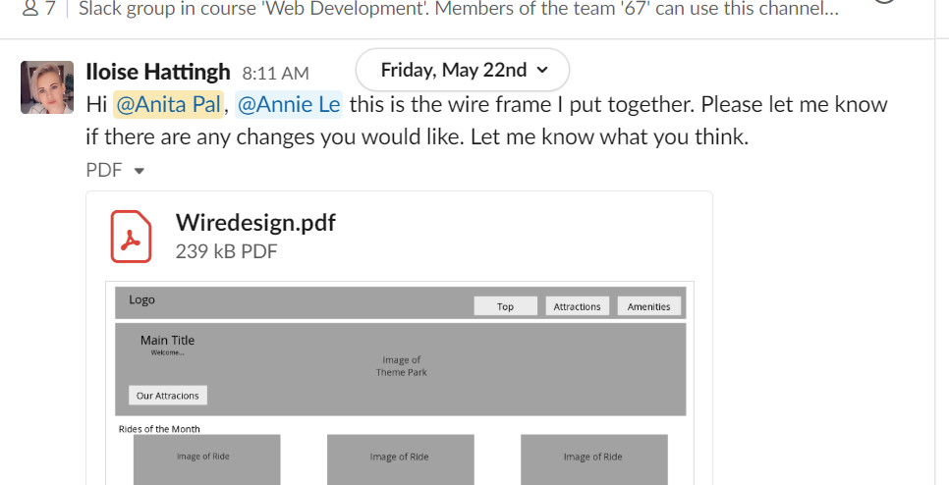

Annie came up with the idea for a map:

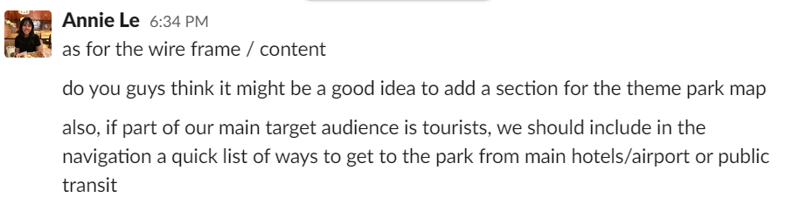

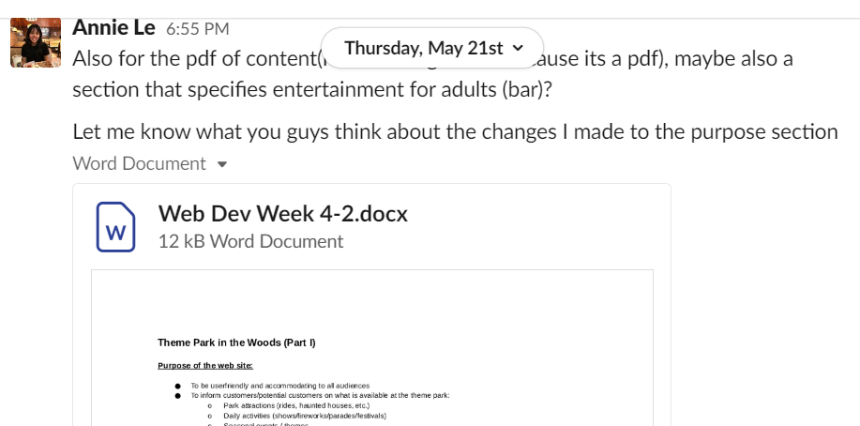

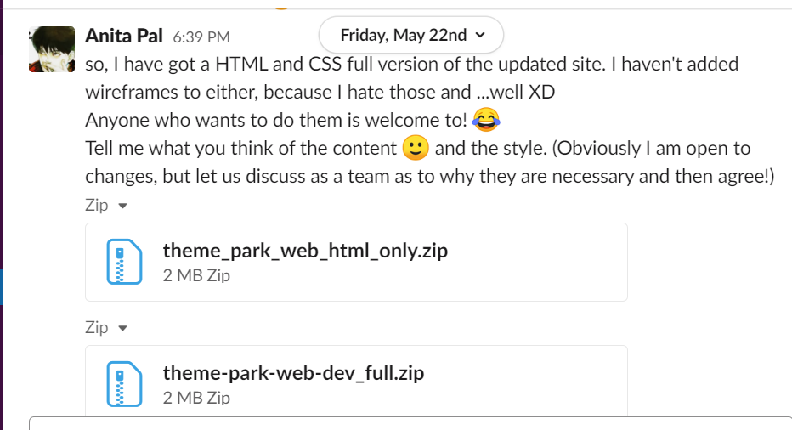

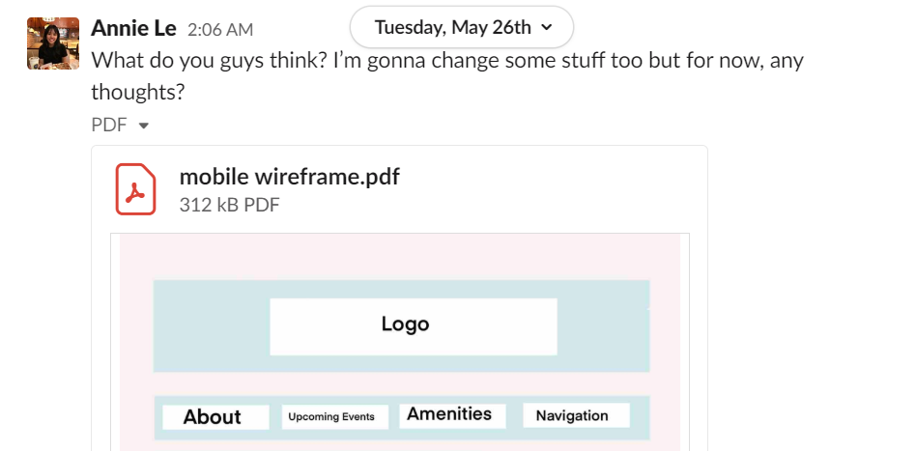

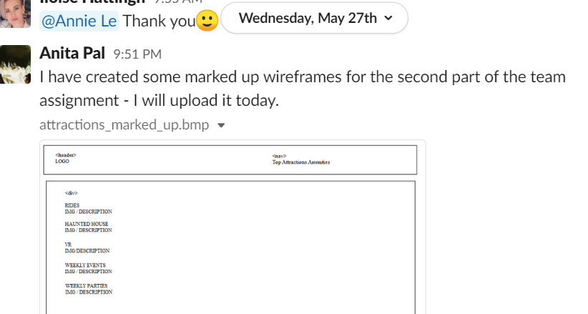

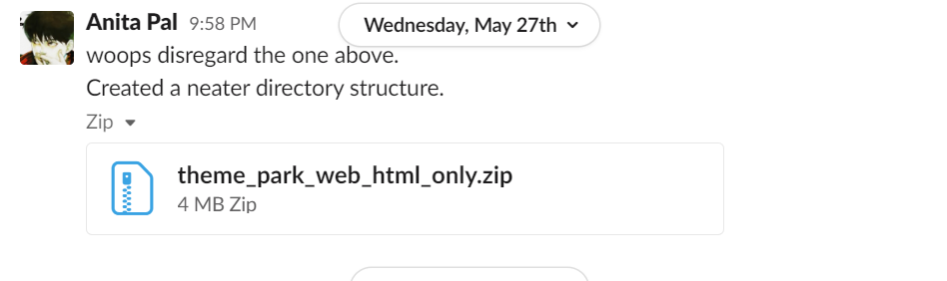

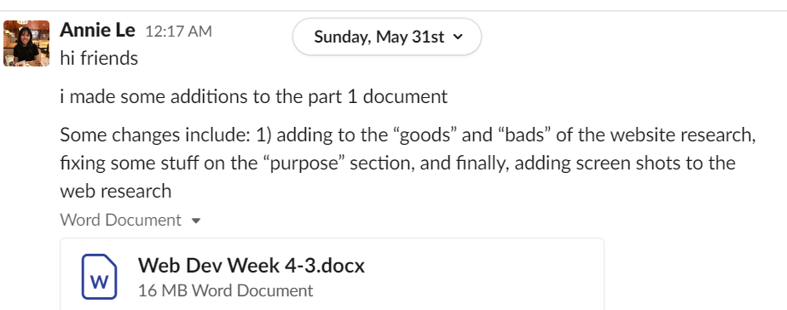

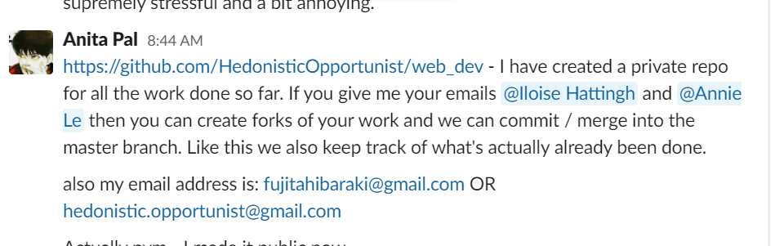

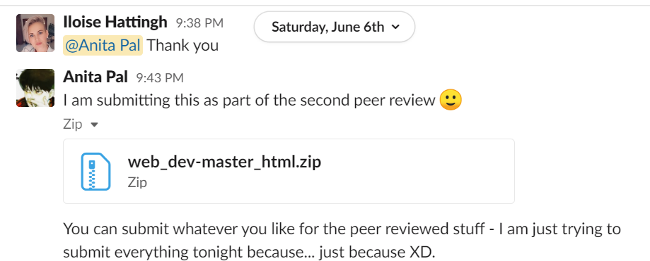

Will and K.M started organising the meetings:

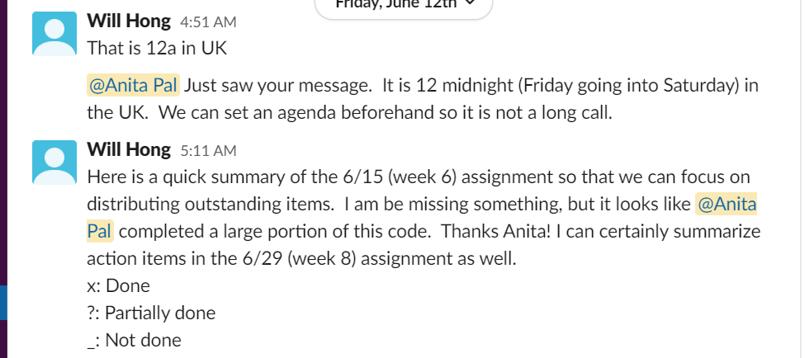

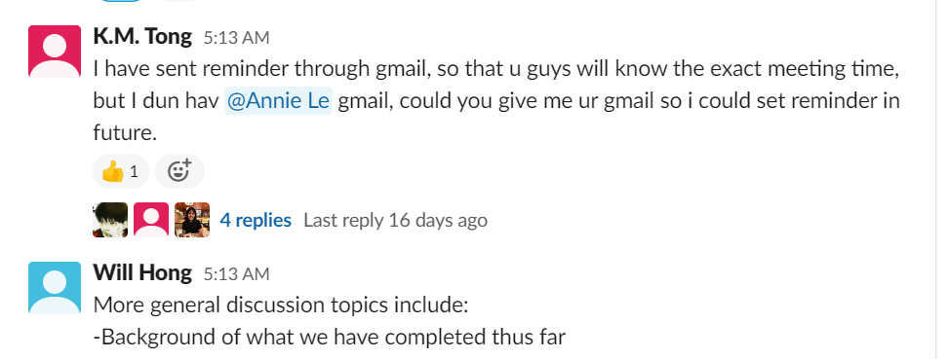

Gary mentioned that images were not working properly on the static website:

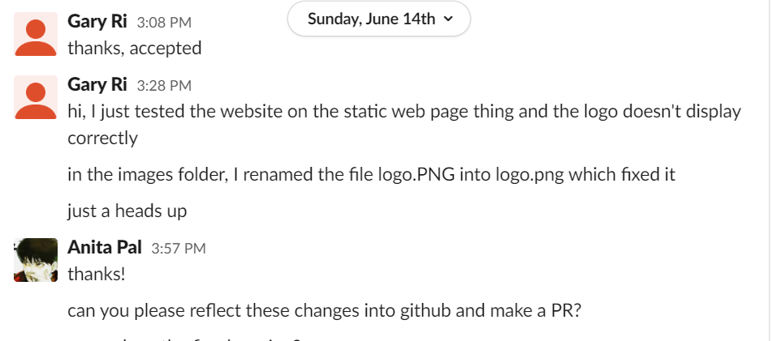

A message I posted on peer feedback re: the usage of CSS:

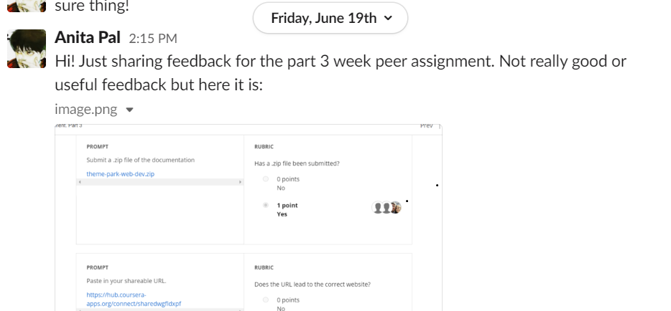

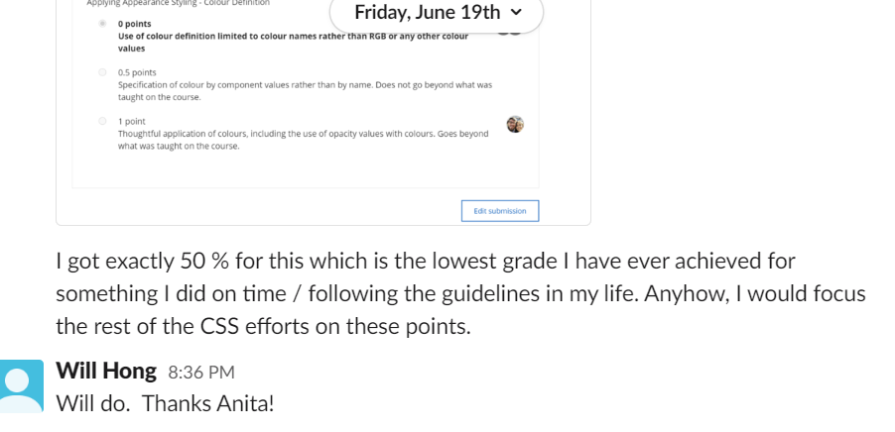

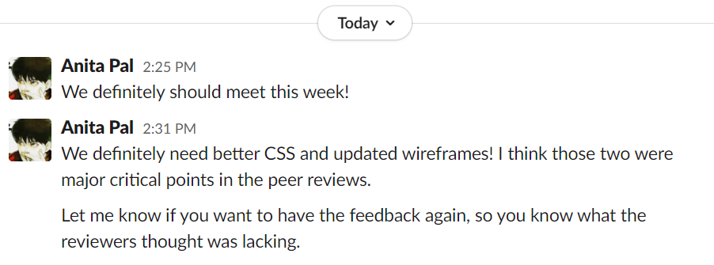

Will taking these ideas on board and improving upon the CSS:

